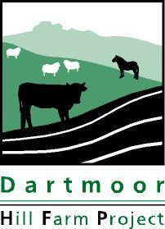
Dartmoor Hill Farm Project

Old Duchy Hotel, Princetown, Yelverton, Devon PL20 6QF
Tel: 01822 890912 Email: hillfarmproject@dartmoor.gov.uk

STANDING ORDER INSTRUCTION
Please complete in block capitals, in black ink and return to your bank or you can set this up via your online banking.

To* Bank
*Insert name of bank here

Please set up the following standing order and debit my/our account accordingly:

Account Name:

Account No:

Sort Code:

Payment Ref: HFP Contributors *insert farm name*

Beneficiary: Dartmoor National Park Authority, Account No 70209155 Sort Code 203047

About the payment:

Frequency of payment: | Yearly*
*Annual payments will be made until you cancel this instruction at your bank

Date & amount of first payment: | DD | / | MM | / | YEAR |  | Amount : | £60.00
Date & amount of on-going payments*: | DD | / | MM | / |  | YEAR | Amount: | £60.00
*If different from the first payment. The Contributors Scheme runs from 1st September

Confirmation:

Account signature(s):  Date: | Farm Name:  Address:

Dartmoor National Park Authority, Parke, Bovey Tracey, Newton Abbot, TQ13 9JQ
VAT reg. No. 679691365. Email: finance@dartmoor.gov.uk

